Installation of java
Step 1: Download Java JDK
- Open a web browser.
- Visit the official Oracle JDK website:
Oracle JDK Downloads
- Download the latest JDK for Windows (e.g., JDK 25).
Step 2: Install JDK
- Double-click the downloaded .exe file.
- Click Next and follow the installation wizard.
- Complete the installation.

Step 3: Verify Java Installation
- Open Command Prompt.
- Type:

java --version

Sample Output: java 25 2026-09-15
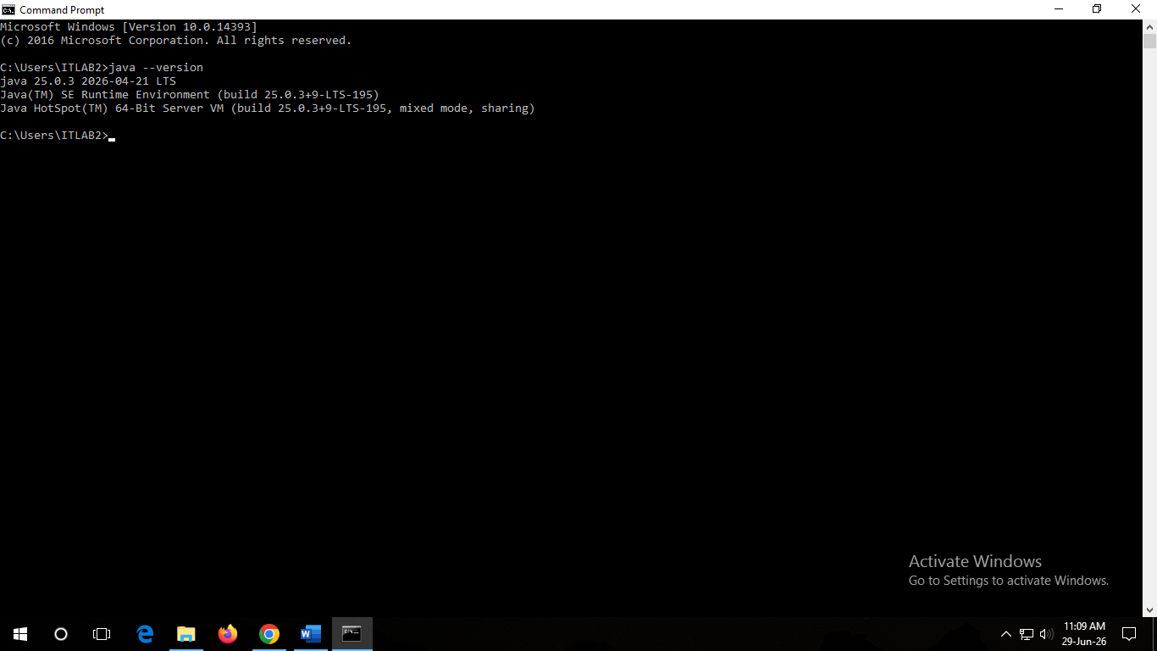

- Check the Java Compiler:

javac --version

Sample Output javac 25

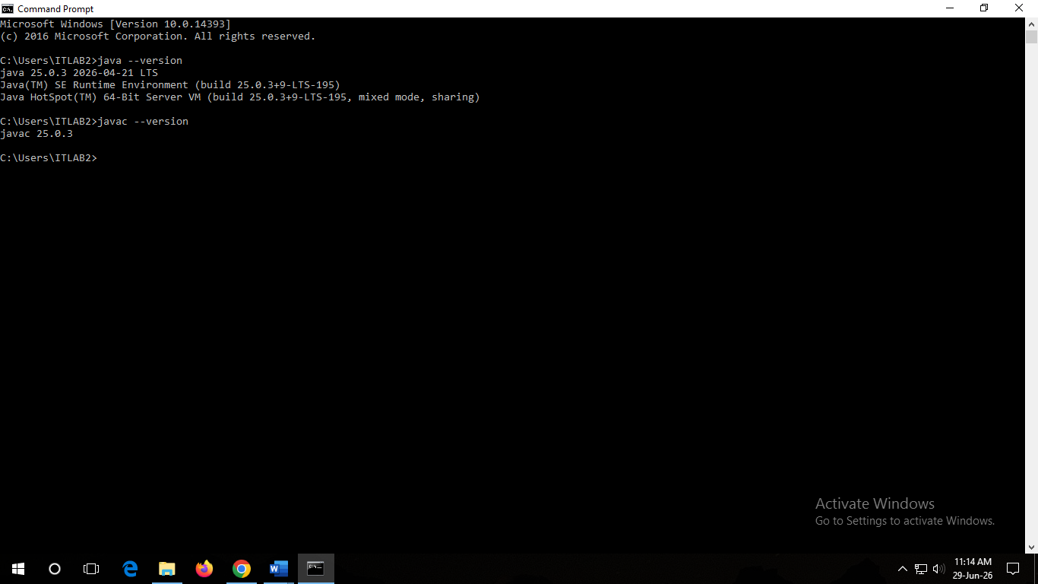

Configuring Java on Windows (Setting JAVA_HOME and PATH)

Step 1: Find Java Installation Path
After installing Java, locate the JDK folder.
Example:

C:\Program Files\Java\jdk-25.0.3

Step 2: Set JAVA_HOME
- Press Windows + R → Type sysdm.cpl → Press Enter.
- Select Advanced tab.
- Click Environment Variables.
- Under System Variables, click New.
Enter:

Variable Name : JAVA_HOME
Variable Value: C:\Program Files\Java\jdk-25.0.3
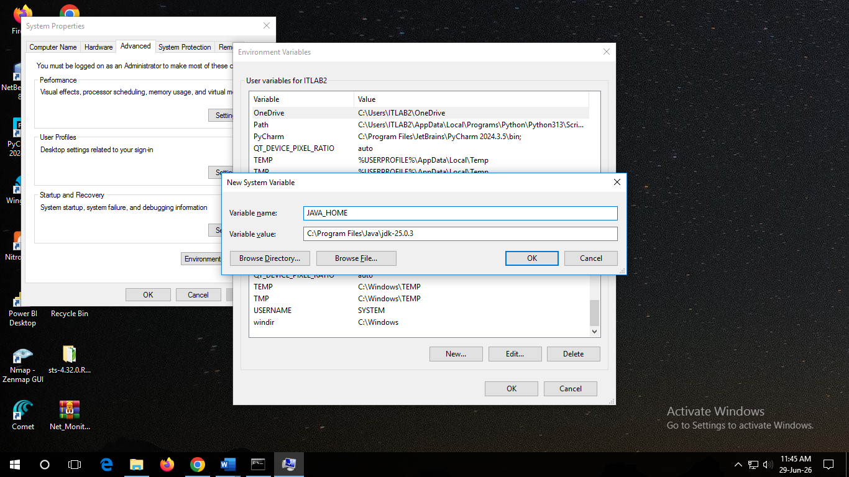
- Click OK.

Step 3: Update PATH Variable
- Under System Variables, select Path.
- Click Edit.
- Click New.
- Add:

%JAVA_HOME%\bin
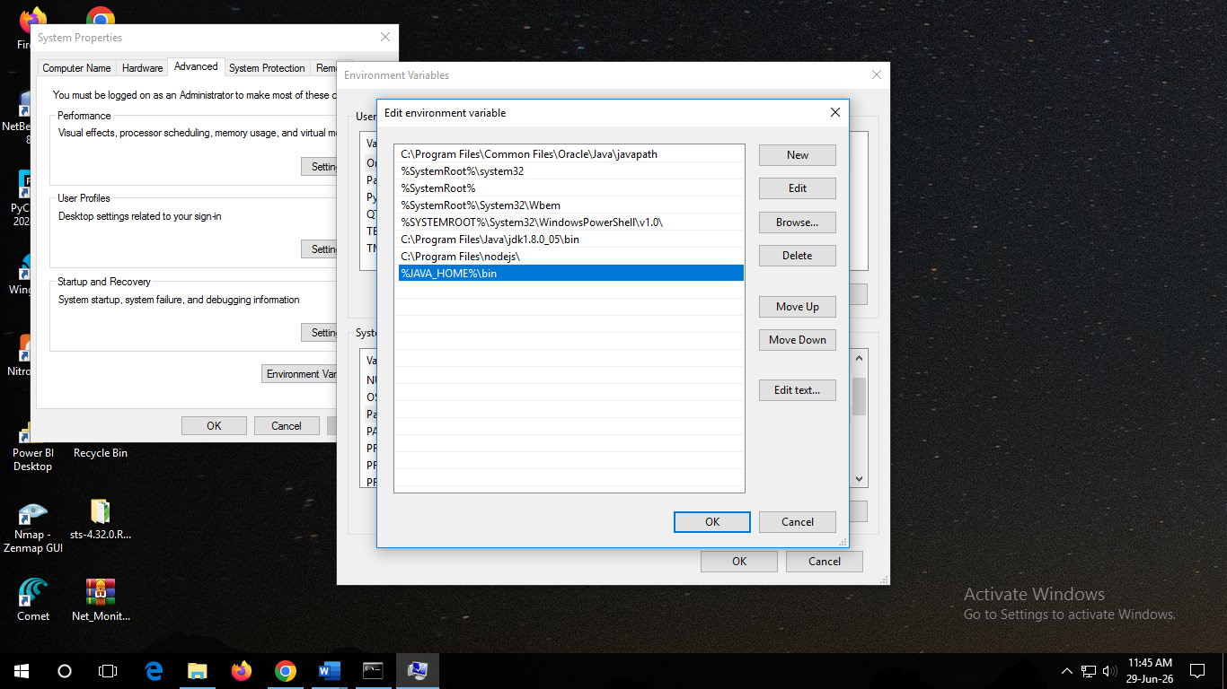
- Click OK → OK → OK.

Step 4: Verify Configuration
Open a new Command Prompt and execute:

echo %JAVA_HOME%

Output:

C:\Program Files\Java\jdk-25
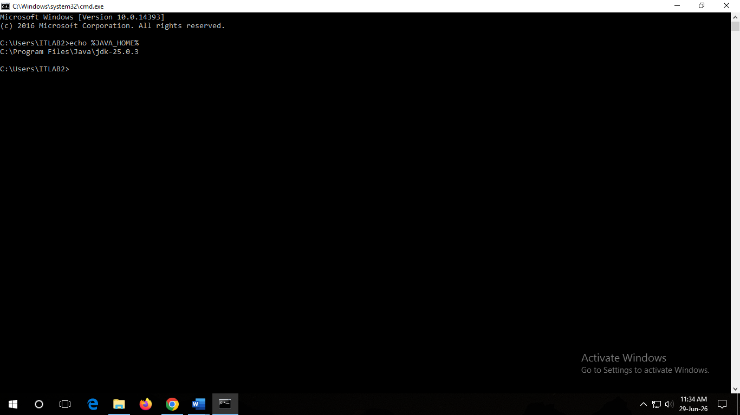
Check Java version:

java --version

Check Java compiler:

javac --version

Sample Output:

java 25
javac 25
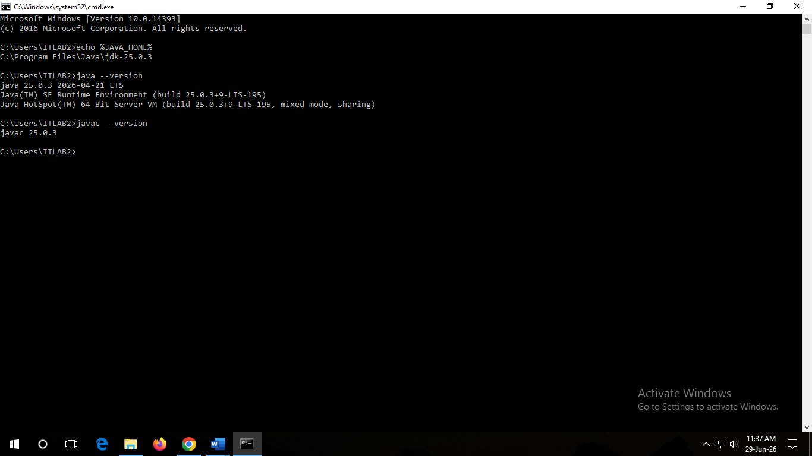

Common Commands

java --version :: Check Java Runtime
javac --version :: Check Java Compiler
where java :: Display Java executable path
where javac :: Display Java compiler path
echo %JAVA_HOME% :: Display JAVA_HOME value

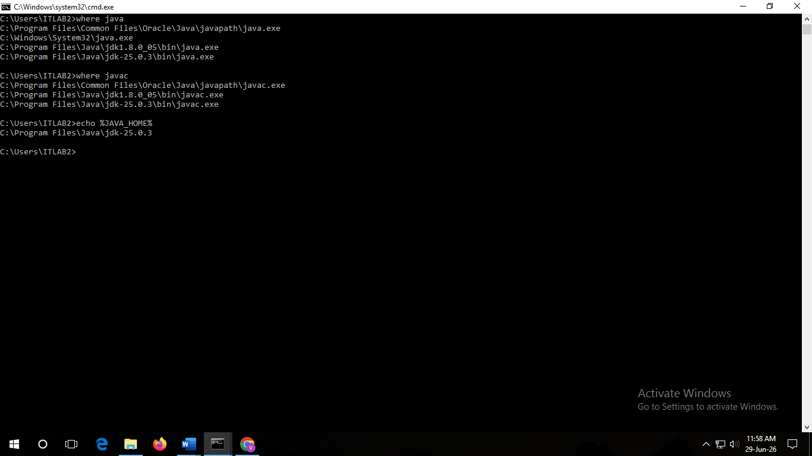
Execution of a Simple Hello World Program (Windows) in Oracle JDK

